1. Login to <https://portal.fabric-testbed.net/signup/1>
2. It will redirect to <https://registry.cilogon.org/registry/> for creating a CILogon user identifier account.
3. Select the Identity provider as “Rochester Institute of Technology”.
4. After creating CILogon, fill in details on the Fabric portal -> it will send a confirmation email after confirming the email ID, and you need to wait for at least 24-48 hours for approval of the FABRIC account.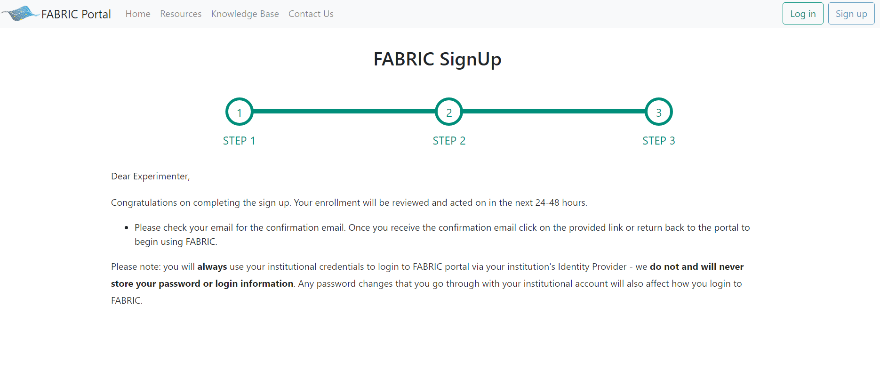5. Upon successful approval of your account, you will receive an email confirming the approval status. This email will also include a link to access the Fabric Portal for further actions.